CICD-PROJECT

Deck of Cards API



Made by:  
Denis Samoilov 321330995

Benjamin Yakobi 323492835

Kostyantin Varenye 321657728

API Description

The API simulates a deck of cards.  
**Features:  
Get new unshuffled deck:**The user gets a new deck that wasn’t shuffled.

**Get new shuffled deck:**The user gets a new shuffled deck.

**Draw cards:**the user draws cards from the deck

**Get new partial deck:**the user gets a deck with only his selected cards.

Test results:

in our project we have done all the tests in one unit the results are the following:

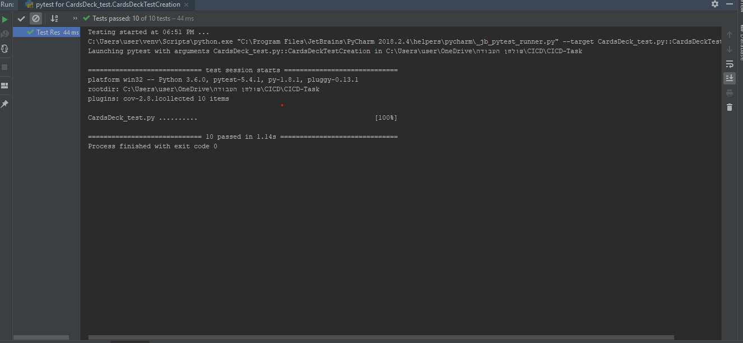Local test results:

CircleCI test results: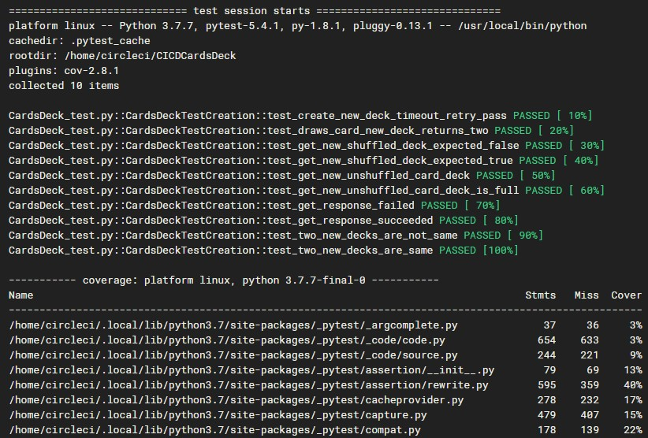 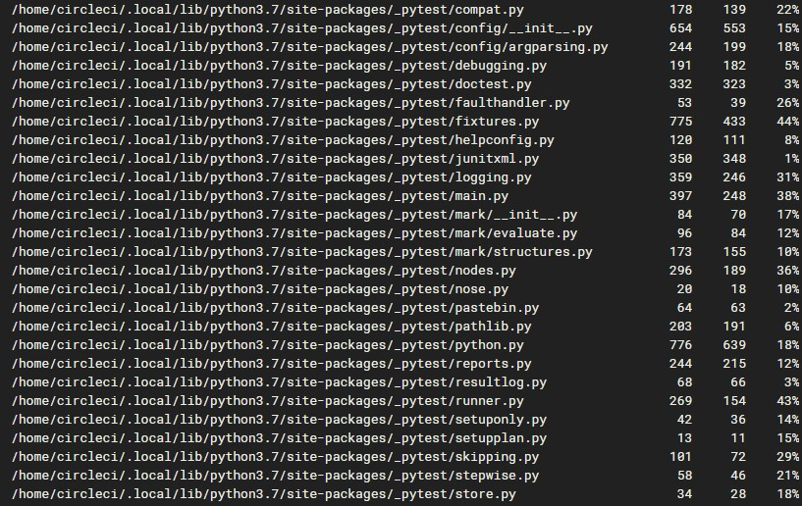



**Cloud service:**

We used the cloud service of hokuro and linked him with our github account.

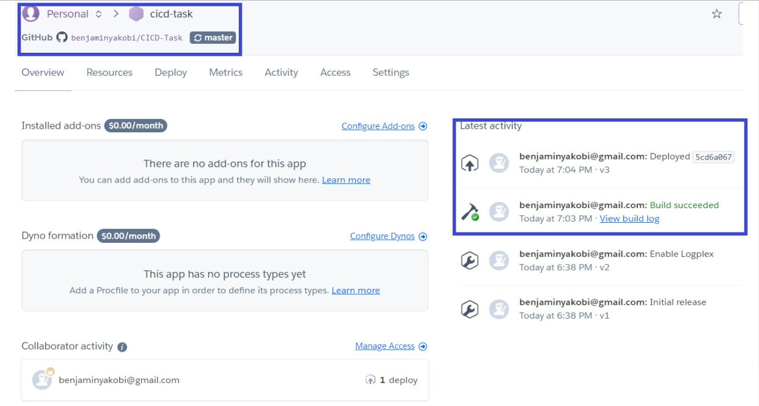

**Link to the Readme HTML:**

<https://htmlpreview.github.io/?https://github.com/benjaminyakobi/CICD-Task/blob/1b3de4b353ce8fff19c0bb8eaea0f338068f994c/README.html>